OPERATOR’S MANUAL

US Small Farm Equipment Co.

Potato Planter Models
P-10M
P-20M

FORWARD

Thank you for purchasing your new US Small Farm potato planter. The US Small Farm P-10M and P-20M potato planters were designed for use on small farms or test plots. They are intended to provide a conveniently sized, light weight, reliable planter to plant potatoes or other tuber crops where larger machines do not fit well. When used as intended, the planter should give many years of service.

The US Small Farm P-10M and P-20M potato planters will provide good performance when used within the guidelines presented in this manual. Please read the manual through before operating the planter. Pay particular attention to any safety warnings. While this planter is simple to operate and maintain, we believe you will profit from the information in the manual by becoming more knowledgeable about your planter.

SPECIFICATIONS CHANGE

Specifications and design are subject to change without notice.

US Small Farm Equipment Co. makes every effort to provide a well designed, well built product made from good quality materials and components for the user. Therefore we attempt to improve the product to give you, the customer, the best value we can. This requires that we make changes in the design of our products to meet the changing needs of our customer base. In meeting these market needs, we reserve the right to make product changes without obligation to purchasers of equipment previously sold.

LIMITED WARRANTY

If within two planting seasons or two years from date of purchase, whichever is less, this planter fails due to defect in material or workmanship, the faulty parts will be replaced free of charge. Modification to the planter or use for purposes other than its intended use will void this warranty. For all warranty and service questions, contact:
Customer Service
US Small Farm Equipment Co.
2117 Big Horn Ave
Worland, WY 82401
Phone: 307-431-9555
Email: ussmallfarm@yahoo.com
www.ussmallfarm.com
SAFETY CONSIDERATIONS:

1. Read and understand the operator’s manual before attempting to use the planter.

2. Do not allow riders on the planter at any time. Make adjustments with the machine stopped. If observation under field conditions is necessary, always have sure footing and a firm handhold. Be sure the tractor operator knows the whereabouts of all personnel.

3. Never work under the planter without blocking or setting the wheels on the ground.

4. Use a large enough tractor. Greater tractor weight and wider tire spacing increase the stability and safety of operation

5. Weight the front of the tractor adequately so there is good traction for steering safely. Empty the seed hopper before transporting at high speeds.

6. Never stand between tractor and planter when the tractor is backing for hookup.

7. Be sure any required safety equipment is in place before travelling over public roads. Be sure the Slow Moving Vehicle sign is clean and visible to overtaking traffic.

8. Exercise extreme care when travelling across or planting side sloping areas.

9. Be aware of sharp parts such as cover discs and protruding levers to avoid serious injury.

10. Keep all fasteners tight. Make it a practice to frequently check the tightness of all critical fasteners such as hitch mount bolts, wheel mounts and lug bolts, especially during the first season of use.

11. Keep all safety decals clean. If they become damaged or illegible, replace promptly.

GENERAL INFORMATION

Many of the service parts needed to keep your planter running smoothly are available at your local farm supply store. Service parts which are not available locally are carried in stock at the factory. Our goal is to keep your planter operating at the times you need it without concern for parts availability..

For service or parts, contact:
Customer Parts and Service
US Small Farm Equipment Co.
2117 Big Horn Ave
Worland, WY 82401

Phone: 307-431-9555
Email: ussmallfarm@yahoo.com
www.ussmallfarm.com

PLANTER SPECIFICATIONS:

Model P-10M Model P-20M
Number of rows 1 2
Planting depth 1” to 4” 1” to 4”
Tractor requirement Cat I or II 3-point Cat I or II 3-point
Seed capacity 200 pounds 400 pounds
Seed spacing 8” to 15” 8” to 15”
Row spacing NA 26” to 36”
Planting speed 2 to 5 MPH 2 to 5 MPH
Planting capability (Approx) 1 Acre/hour 2 Acre/hour
Length 58” 58”
Width 48” 70”
Height 48” 48”
Loading height 40” 40”
Weight (estimated) 450 pounds 835 pounds

PLANTER ADJUSTMENTS

Seed spacing adjustment:

Using the chart below as a starting point, set seed spacing in the row. Actual in the field spacing may be different because of different slippage rates in loose or light soils where greater slippage occurs. Compensate by using a different sprocket set.

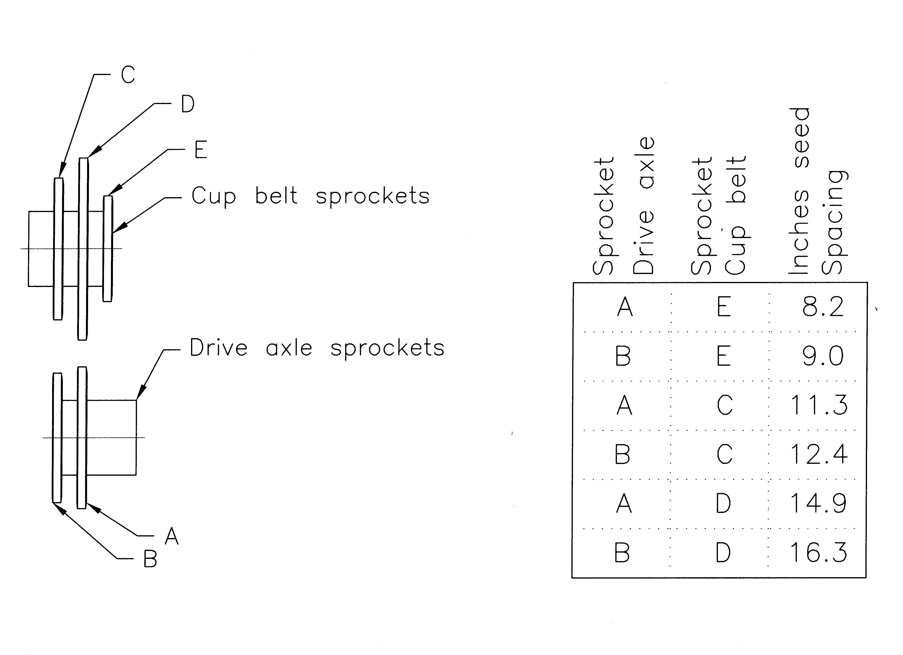

Seed gate:

The seed gate should be set to provide adequate seed in the seed bowl. Too much seed will tend to cause more doubles and too little seed will cause skips. Shortening the seed gate adjusting chain on the left side of the planting unit increases seed flow. The paddle under the flap can be lengthened or shortened to give a wider range of adjustment as needed.

Cup belt:

Tighten the cup belt springs at the sides of the tower so that both springs are compressed the same amount. Tighten the belt only enough to eliminate slippage of the drive roller. Do not overtighten. There should be enough space between the spring coils to pass a sheet of paper. Inadequate tightness can result in uneven seed spacing or complete stopping of the belt. Readjust the splitter after tightening the belt if necessary. If belt slippage occurs, be sure it is not due to an over full seed bowl before tightening the belt. Over tightening of the belt shortens its life unnecessarily.
Splitter:

The splitter between the cups on the cup belt should be readjusted whenever the cup belt is tightened. There should be ¾” clearance between the belt and the splitter at the top of the top roller.

Planting depth:

Set furrow opener depth by loosening the bolt at the front of the shoe bracket, removing the cross-bolt, and sliding the shoe to the desired position. The 3-point hitch top link length and the axle height setting also affect the planting depth. Normally, the planter should set level on level ground for best operation.

Cover disc:

The cover disc width and operating angle can be set by loosening the large nut underneath the center of the disc frame, sliding the disc mount to the desired hill width and using the T-bolt to set the angle. Retighten the large nut. The cover disc hub should be greased each day and at the beginning and end of the planting season.

Row spacing 2-Row:

1. With the planter raised and blocked, set the inner wheels to the desired position. This may require sliding the axle on each unit outward or inward. For row spacings less than 32 inches, the axle may need to be shortened.
2. Set outer wheels so the furrow opener is centered between the wheels. On narrow row space settings, it may be desirable to shorten the axles.
3. Loosen the U-bolts clamping the planting units to the hitch frame. Slide the planting unit to the desired position. Tighten the planting units onto the hitch. Check bolt tightness several times the first day of operation.

Row spacing 1-Row:

When the wheel width spacing of the tractor is too wide to provide narrow enough row spacing, it may be desirable set the wheels at twice the desired row spacing. Then offset the planting unit just as if you were using a 2-row planter. After planting the first pass, return to the starting end in the same wheel tracks, filling in the missing row.
SERVICE

Daily:
Grease cover disc hub bearings.
Grease agitator drive eccentric.
Check for loose cups.
Check air pressure in tires (4.00-8 @20 p.s.i.)
Lubricate chain and idler rollers.

Annually:
If planter is stored outside, remove drive chain and keep covered. Clean grit and deposits from chain and relubricate. Sunlight significantly reduces the useful life of paint, plastics and rubber

Avoid coating the plastic parts with rust preservatives. They can damage some rubber and plastic parts.

Coat furrow opener with plow share protective paint or other soft paint to reduce rusting.
ATTACHMENT - ROW MARKER

Assembly:
1. The marker arms are identical. See Illustration A for the proper orientation to the planter frame. Attach the arms to the mounts with the ½” bolts provided. Leave the bolt free to turn and lock the two nuts tightly together.

2. Remove the nut and lock washer from the eyebolt attached to the end of the ¼” cord. The limit chain will be attached to the marker arm with the eyebolt. Insert the bolt through the hole in the marker arm, replace the lock washer and tighten the nut. Be sure the eyebolt does not contact the porcelain cord guide when lifted to the maximum height. The eyebolt may need to be bent slightly to clear the guide.

3. Attach the scribes to the marker pole with the plates and bolts provided.

Adjustments:
1. Change the marker limit chain length by moving the bolt at the top to a different link.

2. The scribe depth and row spacing can be changed by loosening the 4 bolts holding the scribe in place, relocating, and tightening the bolts.

- The marker in the up position should be at about 60 degrees to the ground when the other marker is down.

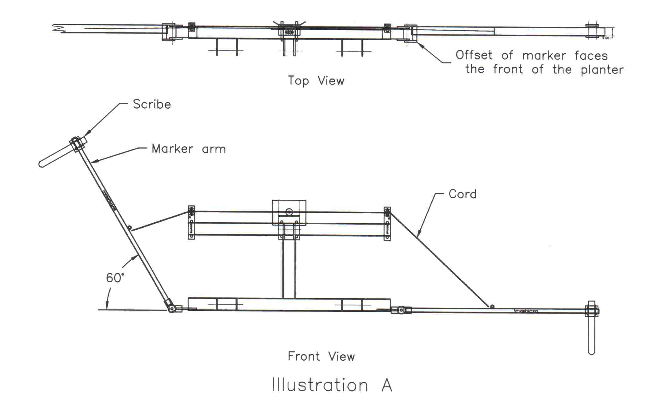
Operation:

CAUTION: ALWAYS BE SURE NO ONE IS NEAR WHEN ACTIVATING THE ROW MARKER.

Pull the loop coming through the center guide quickly enough so that the inertia of the markers will complete the operation. Release the cord just as the knot in the cord nears the center guide. With practice, the timing of the motion will become automatic.

NOTE: Pulling the cord too hard may cause the marker to “park” and then not release when changed the next time. Pulling the cord too slowly will cause the markers to stop halfway down.

